

2 Minute Form
Trip Name: Whangarei Wanderings
Check-in Name and Phone: Date: Branch:
Leaders
Cell Phone Number
VHF Call Sign &/or Vessel Name
Vehicle make, model, registration, colour
General Plan
Note: If plan changes, you must notify your Check-in person.
Latest Time Off the Water
Tide/ Forecast Lake Level
Communications Carried²¹
Communications
Equipment Carried
Trip Report
(Use other side if more space required)

Activity | Kayaking – Whangarei harbour | Centre | North Shore | Location:- Whangarei |  |  |  |  |  | Difficulty¹ |  |  |  | Intermediate
Activity Description | Base ourselves at the Ruakaka Beach Holiday Park – Cabins and tent sites available  Launch at One Tree Point boat ramp,  Paddle within harbour environs either up toward Onerahi, airport (30km) or across the harbour to Parua Bay (15km) or towards the Whangarei Heads (20km).  Returning to starting point.  Actual plan to be confirmed on the day according to weather conditions and abilities of those present. |  |  |  | Leader qualification req.² |  |  | Sea Kayak
Get in Location | One Tree Point boat ramp (near Marsden Point) |  |  |  | Chart/ Map no.⁴ |  |  | NZ521,  (Topo also) |  | Distance |  |  |  | 15 to 30km dependant on actual plan chosen.
Get out Location | One Tree Point boat ramp (near Marsden Point) |  |  |  | Coastguard Channel |  |  | 64 & 16 |  | Nowcasting |  |  |  | 21
Emergency get out ⁵ | Various points around the harbour |  |  |  | Emergency / Coastguard Station |  |  | Whangarei |  | Phone |  | *500 (Auckland)
Emergency get out ⁵ |  |  |  |  | Drinking Water⁶ |  |  |  | Toilets⁷
Emergency Response | Refer Emergency Response Booklet |  |  |  |  |  |  |  | Parking⁸
Specific Equipment Required⁹ |  |  |  |  | Working Communications equipment in this area¹⁰ |  | Cell phone  VHF |  |  |  | PLB
Other resources  and notes¹¹ |  |  |  |  | Weather Parameters¹² | Beginner: no significant surf or swell, wind under 15 knots.  Intermediate: surf or ocean swells less than 1.5 metres or wind under 25 knots.
Previous incidents¹³

Safety Management¹⁴
Hazard |  | Significant?  - E/I/M |  | Management Strategy¹⁵ |  |  |  | Hazard | Significant?  - E/I/M | Management Strategy¹⁵
Cold Water |  | Yes - M |  | Carry spare dry clothes and shelter |  |  |  | Deep Water | Yes - E | Correctly fit PFDs
Medical Conditions |  | Yes - M |  | - Leader has first aid qualification  - Ask customers about medical conditions |  |  |  | Bad Weather | Yes - M | Understand weather forecasts.  Have back up plans or pull out if necessary
Capsizing |  | Yes - M |  | - Correctly fit PFDs  - Skills at performing rescues. |  |  |  | Heat / Sun  Cold | Yes - M | - Protective Clothing (worn), Sunglasses, Hat,  - Sun Screen  - Plenty of drinks  - Windproof/waterproof coverings
Panic |  | Yes - M |  | Ensure conditions match level  of skills |  |  |  | Obstacles | Yes - M | Awareness of reefs, navigational hazards, nets
Other Hazards |  | This is a tidal region with many exposed mudflats at low tide.  Need to be aware of location of channels and that other vessels may have limited ability to manoeuvre. |  |  |  |  |  | Other Vessels | Yes - M | - Understand the “rules of the sea”  - “Be seen” – Have two of the following; flag, brightly coloured kayak, brightly coloured Pfd or hat. At night: an all- round white light & a powerful torch.
Other Hazards |  |  |  |  |  |  |  | Other Hazards
Written up by: | Peter Beadle |  | Approved By: |  | Rob Howarth | Signed: |  |  | Date: | 1/8/2014 | Review in: | 12 months from date of approval

Additional Information Sheet (Optional)
Introduction (A general introduction)
Description (A description of the tour – as if you were selling the idea to someone)
Local Attractions |  | Transport/ Local Operators
 | Contact details |  | Contact details
Local Eateries
 | Contact details
Accommodation/ Campsite Locations |  |  | Facilities
Name |  |  | Cabins |  | Fuel
Phone |  |  | Showers |  | Power
E-mail |  |  | Toilets |  | Water Access
Website |  |  | Laundry |  | Pool
Physical Address |  |  | Water |  | Fires Allowed
Other |  |  | Supplies
Other information
qqqqqq

qq
ww 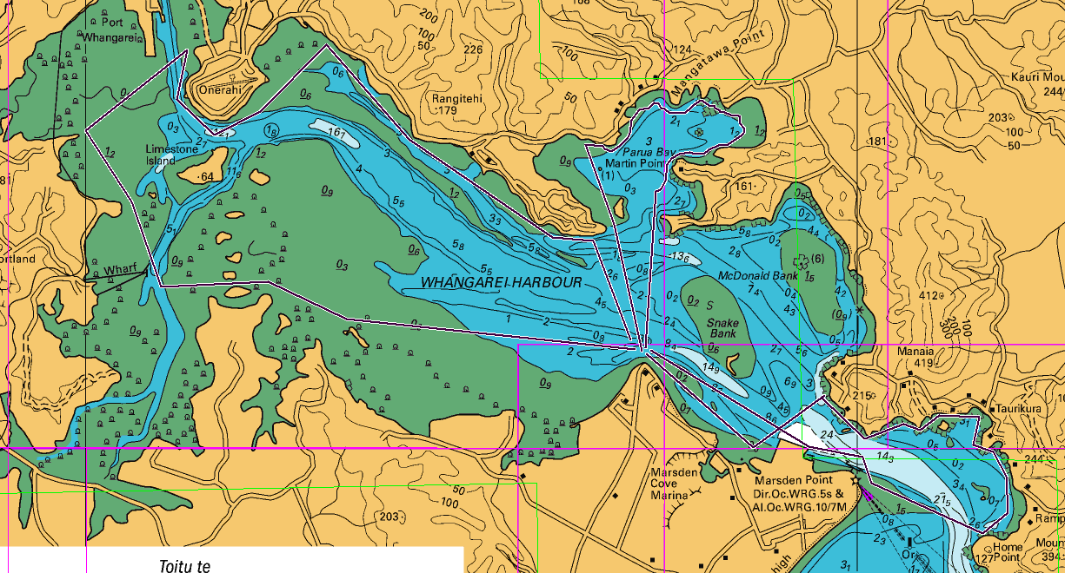

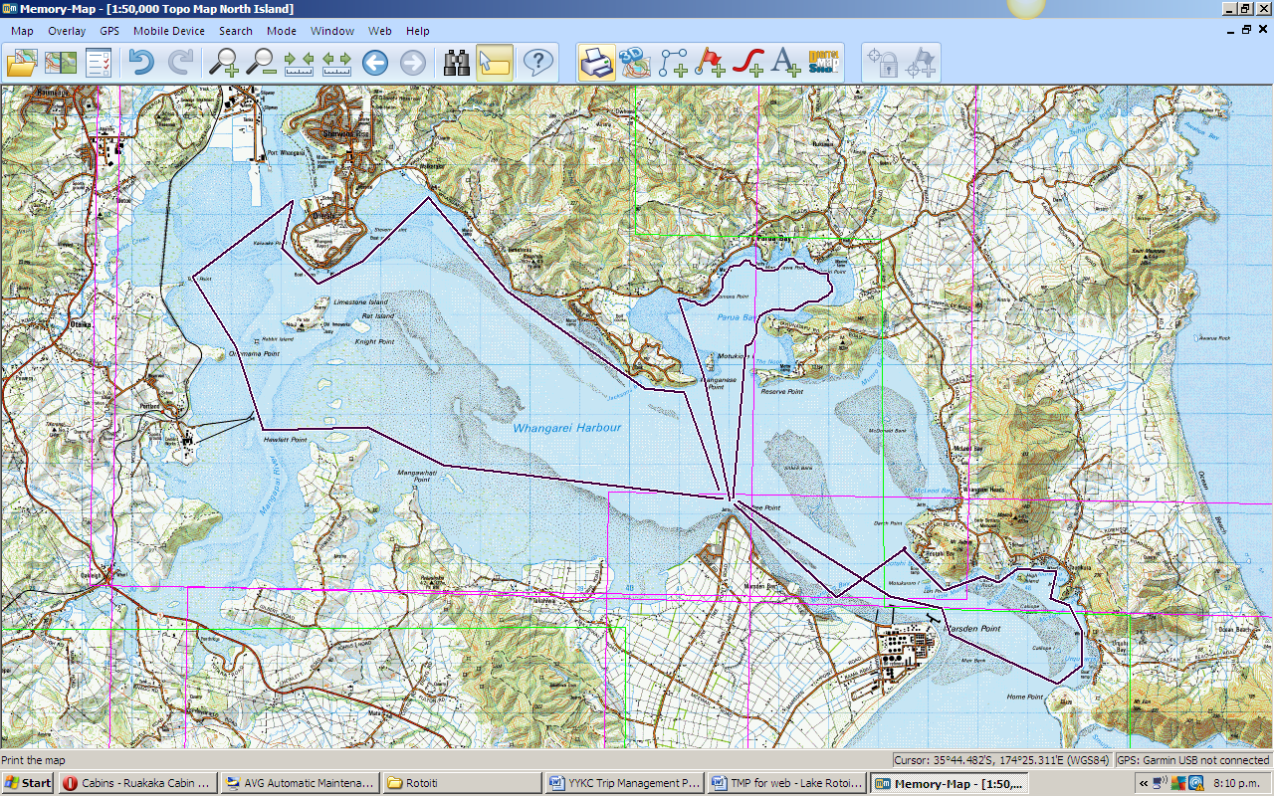

Activity Equipment Check list
Equipment List
- Helmet (rivers & surf) Group Gear
❑ Beanie / hat  Split paddles
❑ Thermals  Repair kit
❑ Paddle Jacket  Fire lighting
❑ PFD  Cooker/thermos
❑ Spray deck  Spare thermals
❑ Booties  Tow system
❑ Water & food  1st Aid Kit
❑ Kayak & paddle  Flares
Group - Oceans & Lakes  Compass
❑ Pumps & Paddle Floats  Charts / Maps
Group - River  GPS (optional)
❑ Throw ropes  Knife (cut rope)
❑ Pin kit & saw  Emergency Shelter

In case of emergency: Dial 111, Mayday :VHF Channel 16

Kayaking Check list

❑ Trip plan
❑ Latest weather forecast
❑ Conditions match skills?
❑ Hyperthermia (hot) &
Hypothermia (cold)
❑ On & off water safety
❑ Environmental concerns
❑ Emergency Procedures include emergency get out.
❑ Working communication devices
e.g. VHF radio, mobile phones, PLB
❑ Specific safety issues for this trip
❑ Participant list
❑ Any medical conditions
❑ All participants keen to proceed?

❑ Trip Plan/ 2-minute form lodged with Ops. Manager

Appropriate wind conditions to run trips:
Novice - no significant surf or swell, wind under 15knots
Intermediate- surf or ocean swells less than 1.5 metre or wind under 25 knots.
Advanced- any condition that is suitable to the trips aims

At conclusion of trip:
Contact check in person
Group Debrief.

Check in Person Ph:
__________________ Mobile
__________________ Work
__________________ Home

Activity Document Cover Sheet

Activity:
Date of Activity:

Activity reports. Is all relevant information present:
– Approved Trip Management Plan (TMP)/ 2 minute form
– Club Trip Participant Sheet
– Weather forecast
– Activity Check List
– Trip report (May be on the 2 minute form)
– Accident / incident reports
Leaders Signature:
Date:

